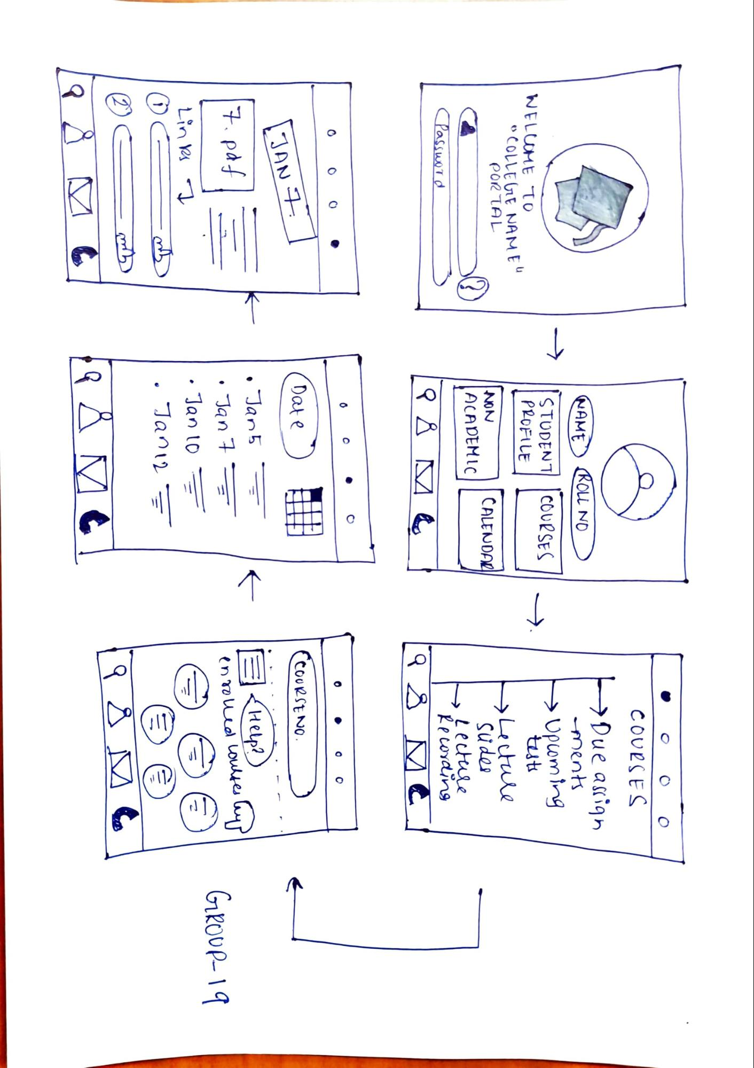

NAME) ROLL NO

STUDENT COURSES PROFILE

WELCOME TO "COLLEGE NAME

POR TAL ca

COURSES. Due assign

ments » Upcoming - tests Lecture

sudes • Lecture

Recording [ 98 MC

INON ACADEMIC

CALENDARI

Password

7.

COURSE NO

JAN

E

<Help?

17.pdf]

=

Date)

Jan5 • Jan 7 . Janto

Janez

F

enrolled courses hay

Links

I

=

©©© GROUP-19

-

mbl.

2) G

mob

PÅ DET